ActionAid Facebook Event Template
Hoping to hold an ActionAid event? Want to put it up on social media? Fill out the ‘your event’ column below and send for approval to get your event posted across ActionAid Australia’s social media platforms.
Note: once you have filled out this template please send to liz.hadjia@actionaid.org for approval and publishing. The approval process can take up to two days so you may need to factor this in to your planning. It’s good to promote an event at least two weeks before the event date.
Component | Notes | Example | Your event (please fill in)
Banner | The banner used on a Facebook event should be relevant to both ActionAid and to the event itself. Examples include an image of a past ActionAid event, an image off the ActionAid website or even your own banner that includes relevant images. Here are some examples of images that have been used for ActionAid Facebook events. If you have trouble finding an image let us know and we can help. | 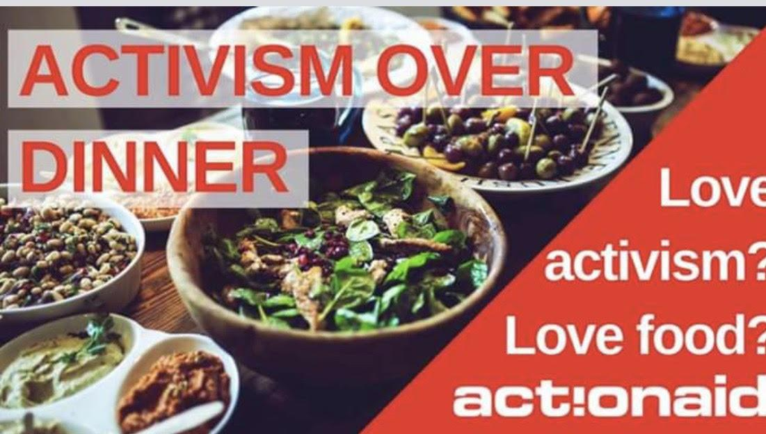  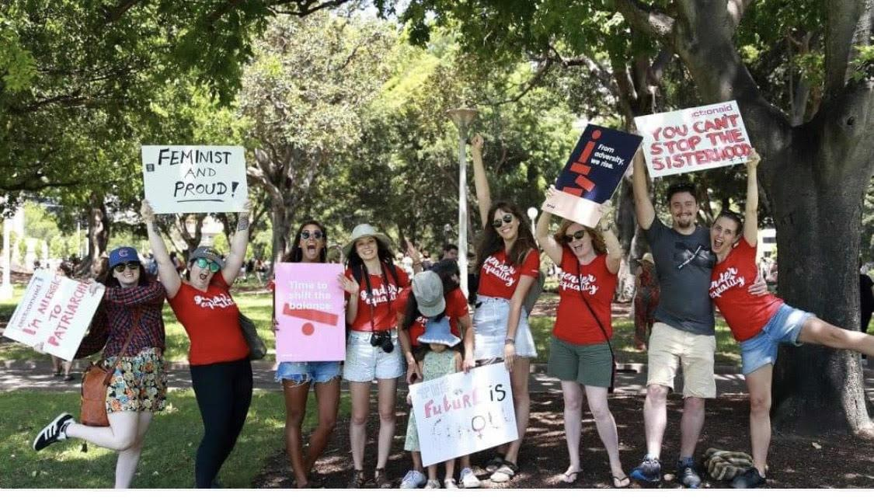
Event title | What will the event be called? Think about some snappy and enticing titles that will stand out on a Facebook feed. | ‘Let’s chat feminism!’  ‘Rock on for women’s rights!’  ‘Discuss and dine: Women’s Rights and Mining’  ‘Brisbane: Activism over Dinner’
Date | Make sure the event is on at a time/day that is accessible to most people wanting to attend. After work hours from 6pm on a weekday are the most successful for most events depending on the event’s nature. Ensure that the duration of the event (start and finish times) is included on the Facebook event page. | Tuesday, 23rd October 2018
Time |  | 6pm-9pm
Duration |  | Three hours
Location | The venue of the event should be included in the text as well as the specific address or basic directions from a nearby public transport station. If you haven’t already confirmed a venue we can help you to find an appropriate venue in the area. | 391 King St, Newtown NSW 2042
Privacy | The events page permissions on Facebook should be set to public so all members of the community have access to the event’s information.
About/Details | Try to keep the details section relatively brief so as not to overload the reader with information  - What is the purpose of this event?  - What will happen at this event?  - What you will get out of coming to this event?  - Link to the RSVP page if necessary. | Love activism? Love food? Join us for an ‘Activism over Dinner’ event.  RSVP here so we can book you a seat at the table: >> https://act.ai/2OwB8lG  We’re building a local group of activists here in Western Sydney who stand in solidarity with women around the world fighting for justice and equality.  We’re hosting a dinner at Grill'd in Parramatta Westfield for anyone in Western Sydney interested in activism for women’s rights.  We would like to open up a dialogue with you and other members of the Western Sydney community about activism. We thought a wonderful way to do this would be to have a dinner together, because we all love food, right? This is an opportunity for us to share a meal and share ideas.  Make sure you RSVP so we know how many to book for >> https://act.ai/2OwB8lG
Tickets | Include details of the cost of the event or note if it is free. Also put details of ticket purchase if this is necessary for your event. | - This is a free event and requires no purchase of tickets.  - Use the link below to purchase your tickets. Each ticket costs $20.

